Учебная дисциплина: Английский язык
для профессии
43.01.09 Повар, кондитер
Тема: Досуг. Имена числительные: Количественные.
Содержание работы и методические указания по выполнению:
Задание №1
Ознакомьтесь с количественными числительными
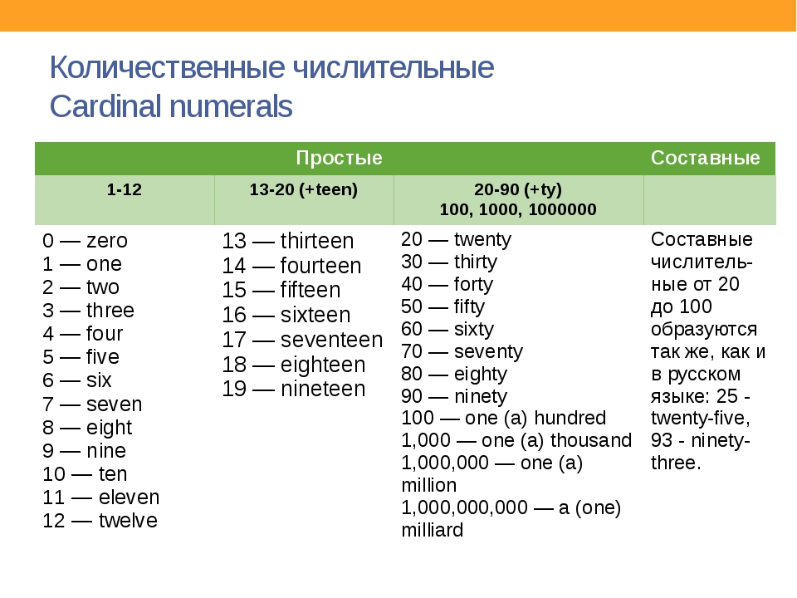

Задание №1 Выберите правильный вариант:

Choose the correct variant
1.145 _____ live in the Russian Federation.
- millions people
- millions of people
- million of people
- million people
2._____ are starving in the world today.
- Thousands people
- Thousands of people
3.You are _____ who asks me this stupid question.
- fifth
- the fiveth
- the fifth
- five
4.Two _____ of my income I spend on my pet’s food.
- twelve
- twelfth
- twelves
- twelfths
5.Every _____ person in our company is not satisfied with his salary.
- three
- the third
- third
6.Ok! See you on _____ of April.
- the twentyth-seventh
- twenty-seven
- the twenty-seventh
7.It is _____ hit. I like such songs.
- his the third
- his third
- the third his
8._____ of the territory is covered with ice.
- one thirds
- one third
9.This bouquet costs _____ dollars!
- two hundreds
- two hundred
- two hundred of
10.Two thirds of my work _____ dedicated to the theory of the subject.
- are
- is

Оценка______________ Дата____________________
Преподаватель:________________________ Котенев И.С.

