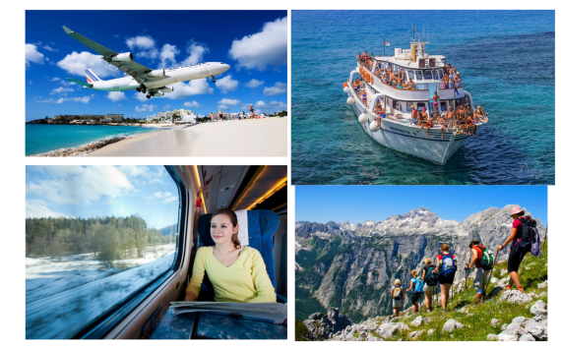
Конспект урока по теме "Journey" к учебнику Rainbow English 10-й класс

Цель урока: Формирование основных языковых компетенций на уроке английского языка.
Задачи:
Образовательные
- научить учащихся использовать изученную лексику по теме «Путешествие» и отработать ее употребление в речи, при ответах на вопросы, аудировании, работе с текстом.
Развивающие
- создать условия для развития памяти, умения правильно обобщать данные и делать выводы.
- формировать умения правильно и связанно переводить текст, понимать текст на слух.
- развивать внимание и восприятие.
Воспитательные
- формировать интерес учащихся к окружающему миру.
- научить учащихся работать в паре, группе, слушать друг друга.
Тип урока: Урок комплексного применения знаний с использованием электронно-образовательных ресурсов. (комбинированный)
УУД:
Личностные:
- формирование познавательных мотивов обучающихся
- развитие мысленного воспроизведения ситуации
Регулятивные:
- владение навыками самоконтроля и самооценки своей деятельности
Коммуникативные:
- продуктивное взаимодействие обучающихся в решении поставленной задачи
- участие в небольших устных высказываниях
Познавательные:
- высказывание предположений, обсуждение проблемных вопросов.
Форма урока: - урок решения практических задач.
Форма работ: - фронтальная, индивидуальная, групповая.
Оборудование:
- учебник 10 класс Просвещение, 2021.
- мультимедийный проектор для просмотра слайдов.
- презентация
- компьютер для проведения аудирования.
- карточки для аудирования, карточки со словами на русском языком и английском азыках.
Этап урока | Содержание этапа урока | Слайды и изображения
1.Организационный момент | Good morning. Glad to see you. Sit down. How are you today?
2. Постановка цели урока | Look at these pictures and try to guess what we are going to speak about.  P1: travelling by plane  P2: on foot  P3: different ways of travelling
3. Работа с лексикой по теме | You're right. So, today we are going to discuss why people travel and what ways of travelling they can use. Travelling is becoming more and more popular nowadays. Can you tell why people travel?  P1: People want to see new places and meet new people  P2: They can try local cuisine and have a rest lying on the beach  P3: We can go sightseeing and practise the language  P4: People travel on business and for pleasure, they visit their relatives and friends.  T: On your desks you see cards with Russian and English words on travelling. Let's translate the words into English and Russian (Ученики переводят слова и выражения)  T: Fine. By the way, have you heard about hitch-hiking? Do you know what it is?  P1: It's a way of travelling, when people go on foot with their rucksacks and stop the car to reach their destination  P2: It's popular among students in European countries  P3: I think it's great as you can stop where you want and get new experiences  P1: On your desks you see cards with Russian words on travelling. Translate the words into Russian and into English ( Ученики переводят слова) | Приложение 1. (карточки со словами)
4.Аудирование | Now let's listen to some texts about hitch-hiking. (У каждого ученика карточка с заданием по аудированию) You'll hear six texts. Your task is to find the correct answer to each statement. One statement is extra. You'll hear the texts twice. Be very careful. Are you ready? (Учащиеся прослушивают тексты). Now I'll give you the correct answers and you'll check the answers of your partner and give marks to him. One point is for each correct answer. Thank you for your job. (Учитель собирает карточки). | Приложение 2. (тексты для прослушивания)  Приложение 3 (карточки для аудирования).
5. Работа с текстом. Чтение и перевод текста | We've spoken a lot about travelling and I'd like you to read and translate the text at page 82. It was your home task.  T: Now let's read and translate the text. (Учащиеся читают и переводят текст)  T: Good job. I'd like you to decide if the statements are true or false. Let's do exercise ex.2 at page82 (Учащиеся выполняют упражнение)
6. Монологические высказывания. Развитие навыка устной речи | T: That's fine. What about you? Can you tell us about your interesting trips, excursions or journeys?  P1: Last summer my family and I went hiking to the mountains. We lived in a tent by the river. My dad went fishing and we cooked the tastiest soup I've ever had. We admired the nature, swam in the river, made a fire at night and had a great time. The only problem was mosquitoes and insects flying everywhere and biting.  P2: My unforgettable trip was to France two years ago. I went there with a group of teens from my town. There were a lot of guided tours around Paris, we visited the Louvre, the Eiffel Tower, and of course the Disneyland. It was really cool. I met a lot of English-speaking people and could communicate with them. I bought a lot of gifts and souvenirs, I was impressed by Paris and my trip. I liked everything the airport, flights, food, hotel, excursions and especially my new friends.  P3: Last winter we visited our relatives in Moscow. My parents booked tickets in advance, it took us four hours to get to Moscow from Gorno-Altaysk. We spent a week in Moscow and our relatives showed us many interesting places. Unfortunately, the weather was stormy and we couldn't enjoy our trip, but nevertheless it was great. Moscow looked fantastic with New Year decorations and illuminations.
7.Подведение итогов | T: Thank you. I hope you got some information, new experiences, unforgettable impressions from your trips and journeys. Our lesson is coming to an end and I'd like you to answer my question. Does travelling make our life interesting? Is it useful or useless?  P1: Of course, travelling is very interesting, as you meet new people, make new friends.  P2: If you travel abroad, you can compare different cultures, tell about your country, master your language.  P3: Travelling makes our life exciting. It's great to come back home after long trips, I travel a lot with my family, every time get a lot of impressions from my trips/
8. Домашнее задание. Выставление оценок | Now I'd like to thank you for the lesson. You were very active and hard-working and I give you excellent marks. It's time to write your home task. Imagine you are the author of the travel diary on p.82. Write a postcard home from Bhaktapur (50-60 words) Ex.8 p.83
9. Рефлексия деятельности | Now, I'd like you to tell me what new things you've learnt today.  P1: Today I've learnt some new words and expression.  P2: Now I know about hitch hiking and I'd like to try hitch hiking with my friends.  P3: I understand the importance of the travelling and try to visit as many countries as I can. | Приложение 4
10. Заключительный этап | The lesson is over. Good bye.

