Тема: Профессии. Повторение ранее изученной и введение новой лексики.
Цель урока: способствовать формированию навыков устной речи по теме «Профессии».
Задачи: Учебные:
- Совершенствовать произносительные навыки;
- Активизировать в речи, изученные ранее лексические единицы;
- Формировать навыки чтения с поиском заданной информации;
- Познакомить с новыми лексическими единицами;
- Способствовать формированию навыков монологического и диалогического высказывания по теме урока.
Развивающие:
- Развивать внимание, память, языковую догадку;
- Развивать самостоятельность мышления;
- Развивать воображение.
Воспитательные:
- Воспитывать уважительное отношение к различным видам профессиональной деятельности.
Оборудование: интерактивная доска, презентация с различными видами заданий.
Ход урока
1. Организационный момент. (1-2 мин)
Teacher: Good morning, boys and girls!
I am glad to see you! What day is it today? What date is it today? What is the weather like today? What season is it now? Who is absent today? What’s the matter with…? What do you do to be healthy?
2. Фонетическая зарядка (2мин)
Teacher: I’d like you to listen to some tongue twisters and guess what the topic of our lesson is.
How many cookies could a good cook cook?
A fisherman wished a good fish.
Singer Sammy sang songs.
Editor Eddy edited it.
Can you repeat them? Who can name the theme of our lesson today?
( Pupils: We think the theme is professions.)
3.Активизация лексических единиц по теме. (6-7 мин.)
Children, let’s review some words of this topic. We studied them in the elementary school.
Look at the first slide and try to guess these words. (Slide 1)
(Посмотрите на первый слайд и попытайтесь угадать эти слова).
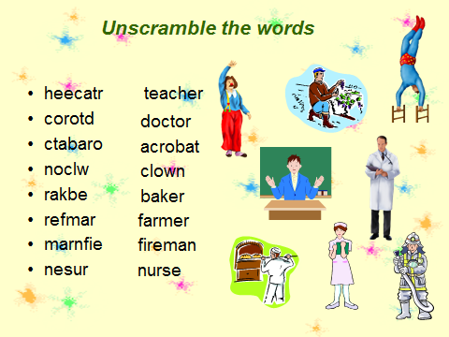
(Oh, excellent. You guessed all words.) (Отлично. Вы угадали все слова).
Teacher: How do you think what they are doing at work? (Как вы думаете, что они делают на работе?)
F.ex.: A builder build houses. – Строитель строит дома.
Look at the second slide and match the words and sentences.
(Посмотрите на второй слайд и сопоставьте слова и предложения). (Slide 2)
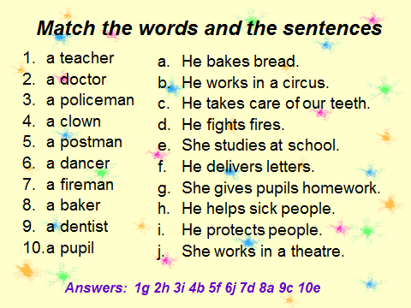
4.Физкультминутка (2мин)
Head and shoulders, knees and toes(3 раза)
Head and shoulders, knees and toes
Eyes, ears, mouth and nose.
5. Совершенствование навыков чтения и аудирования. (18 мин)
Teacher: We know people of different professions: a doctor, a teacher, an engineer, a salesperson, a librarian, a businessman and others.
These professions are very important because we can’t do without these people. They do different and useful work.
Teacher:
Now I’d like to divide your class into 2 groups and you will do some tasks.
1 task:
Глагол to be. You should fill in the blanks one of the verbs (am, is, are). Who will be faster?
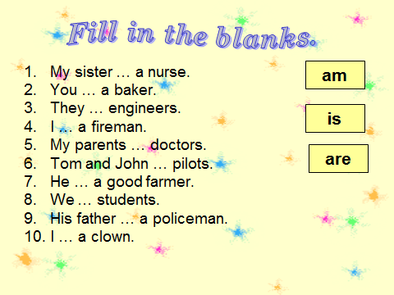
The second task: read and guess the riddles.
- Hi! I want to tell you about profession of my dream. It is interesting and romantic. I will work in the sky in a big white plane. There will be many passengers. I will help people to travel and see new places. Do you guess?(pilot)
- My parents have a large library. I like reading books. My favorite subject is literature. My beloved writers are Mark Twain and Jack London. I have a dream. I want to work with many books and give them to people. My future profession is… (librarian)
- Hi! I want to tell you about my future profession. People of this profession are strong and brave. They work hard. They help people in difficult situations. I like sport. I want to be very strong. I can do many things. My dream is to help people by day and at night. What is my future profession?
(policeman)
- This person always communicates with sick people. If you have a cold, a headache, a stomachache you go to him. He treats people. He gives you medicine to be healthy. She works in the hospital. (doctor)
- He is very strong, clever, and athletic. He goes in for sports. He takes part in different competitions. He can win or lose a game. (sportsman)
- She is an intelligent, well educated, creative, kind, hard-working person. She teaches different subjects to children. She works at school. (teacher)
The third task: Say they are true or false. Correct the sentences.
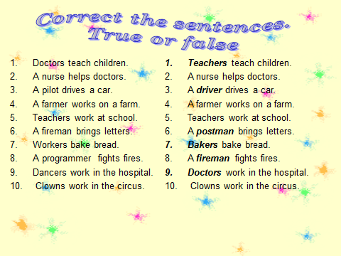
Now I can name the winner: it’s the group …….
- Повторение пройденного на уроке. (5-6 мин)
Let’s review what we studied today at the lesson.
Look at slide 6. You should answer the questions.
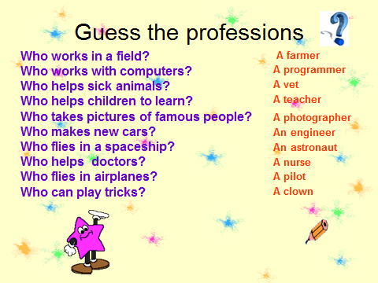
- Рефлексия. (2-3 мин)
I have given you the cards with some sentences. Complete them. Appreciate your work at the lesson today. (Оцените свою работу на уроке).
- I worked at the lesson ……
- I knew much information about ….
- I got ……
- Next lesson I will work ……

Teacher: Thank you, children. You have done a good job. I’ll give you good marks. Your home task will be ex. 1, 2, 3 at page 102 in your Activity books. Open your diaries and write it down.

