ЗАНЯТИЕ 1.

Instructions and Guides: practice of reading and translating

1. Match a–f with 1–6 to make rhythms.
1) flows  2) fan  3) true  4) cost  5) pin  6) rank | a) tank  b) most  c) thin  d) goes  e) through  f) pan

2. Read the text:
A radiator is a type of heat exchanger. It is designed to (transfer, deliver, replace) heat from the hot coolant that flows through it to the air blown through it by the fan.
Most modern cars use aluminum radiators. These radiators are made by brazing thin aluminum fins to flattened aluminum (tubes, columns, wires). The coolant flows from the inlet to the (outlet, exit, way out) through many tubes mounted in a parallel arrangement. The fins conduct the (heat, temperature, warm) from the tubes and transfer it to the air flowing through the radiator.
The tubes sometimes have a type of fin inserted into them called a turbulator, which increases the turbulence of the fluid flowing through the tubes. If the fluid flowed very smoothly (through, across, over) the tubes, only the fluid actually touching the tubes could be cooled directly. The amount of heat transferred to the tubes from the fluid running through them depends on the difference in temperature (between, among, near) the tube and the fluid touching it. By creating turbulence inside the tube, all of the fluid mixes together, keeping the temperature of the fluid touching the tubes up so that more heat can be extracted, and all of the fluid inside the tube is used (effectively, effective, well).
Radiators usually have a (tank, piston, drum) on each side, and inside tank is a transmission cooler. The transmission cooler is like a radiator within a radiator, except instead of exchanging heat with the air, the (oil, petrol, air) exchanges heat with the coolant in the radiator.

Answer the questions.
1. What materials are radiators made of?
2. What is a turbulator used for?
3. What does the amount of the heat transferred to the tubes from the fluid running through them depend on?
4. How can you explain the work of transmission cooler?

3. Match the names of the tools to the pictures.
sander, heat gun, angle grinder, drill, screwdriver, drill press, lathe, bench grinder, table saw
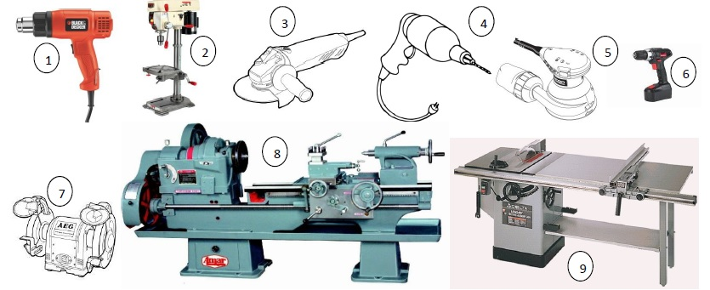

4. Learn the following units and fill in the gaps in the sentences below.
Units of time  60 seconds = 1 minute  60 minutes = 1 hour  24 hours = 1 day  7 days = 1 week  52 weeks = 1 year  365 days = 1 year | Units of length  12 inches = 1 foot = 30.5 cm  3 feet = 1 yard = 91 cm  1760 yards = 1 mile = 1609 meters  1 inch = 2.54 cm  1 meter = 39.37 inches
Units of weight
16 ounces (oz.) = 1 pound (lb.)
1 kilogram = 2.2 lbs
Units of area
1 square meter = 10,000 square centimeters
Units of volume
1 cubic meter = 1,000,000 cubic centimeters

1. The speed of the car is 120 km per hour which is equal to … meters per second.
2. The length of the wrench is 20 centimeters which is equal to …meters.
3. The weight of the wheel is 15 kilograms which is equal to … pounds.
4. The volume of the engine is 2,000 cubic centimeters which is equal to … cubic meters.
5. The length of the car is 3.2 meters which is equal to … inches.
6. The warranty for this equipment is 2 years which is equal to …weeks.
7. The load capacity of the dump truck is 8 tons which is equal to ... kilograms.

