Открытый урок английского языка в 9 классе по теме «Музыка в моей жизни» (проектная методика).
Цель: защита проектов по теме.
Задачи: развитие навыков монологической речи, чтения; привитие эстетического вкуса, интереса к музыке; развитие художественного вкуса.
Оборудование: магнитофон, постеры различных певцов и музыкальных групп, проекты, карточки, текст песни “Yesterday”.
T. Hello, children. I am glad to see you. Hello, dear quests. We are glad to see you, too. Today we are having an unusual lesson because the students have prepared some projects and we are going to listen to them. But first of all I want you to guess one word. Look at the blackboard. You can see a list of words. There is one missing letter in each word. Please write down each missing letter.
sentimental
spiritual
sensational
enthusiastic
fascinating
(учащиеся по очереди вписывают пропущенные буквы и называют получившееся слово)
So, you see the word MUSIC, and our topic is “Music in my life”.I think you are ready for our lesson and have a good mood. Our today`s lesson is dedicated to music. It`s impossible to live without it, it follows us everywhere, it is in our hearts, feelings and souls. But we can not discuss all aspects of music during one lesson. Please express your opinion: what will we speak about during our lesson?
Yes. Today we shall speak about different styles in music. On the blackboard you can see a charming quotation:

“Music is the universal language of the world”
H. Longfellow

«Music is a free art, an open-air art, an art boundless as the wind, the sky, the sea».
(Debussy)
What types of music do you know?
T. But what role does music play in your life?
T. What does music reflect?
T. Where can we hear music?
T. What do you think about when you listen to music?
T. Who is your favourite singer?
Do you know any English singers?
T. I am glad that you are fond of music. When I listen to music I can think about nothing but music. As far as you know music may be different. I see you like music and now it is high time to listen to your projects. Be very attentive because you will have a small test.
(каждая группа представляет свои музыкальные проекты)
1 Elvis Presly
P. We are going to tell you about rock. It is my music! As for me I prefer rock all the year round, because it can express all kinds of my mood. I can find a firm support in rock. Within this music I feel strength and stability. Rock music, or, rather rock-n-roll, appeared in the 1950-s. The first rock music is connected with the names of Elvis Presly, Chuck Berry, The Beatles, The Rolling Stones, Eric Clapton, The Doors and some others. The70-s were the time of revolution in rock music. Lead Zeppelin, Deep Purple, Uriah Heep, BlackSubbath told the world about the beginning of new era of hard rock. I’d say that, of course, tastes differ and everybody is fond of particular genre of music. But I am mad about rock. And now let’s listen to rock music.
(звучит фрагмент)
2 The Beatles
Песня Yesterday

3группа
P1. Let me introduce our group. We are fond of jazz. Jazz was created in the United States by black Americans. It is a mixture of many different kinds of music. It is a combination of the music of West America, the work songs the slaves sang, and religious music. Jazz bands were formed in the late 1800-s. Improvisation is an important part of jazz.
P2. Jazz became more and more popular. Today, people all over the world play jazz. People who like jazz always remember American jazzman Louis Armstrong. And now let’s listen to jazz.
(звучит фрагмент)
3группа
P3.I want to tell you about classical music. As for me I have found classical music the closest to my soul. Most of the people of my age would think I’m a bit mad to love Strauss, Tchaikovsky, Bach, Mozart, Beethoven in place of Eminem or Tamy. But I find classical music relaxing. This music has been living for centuries. It is heard in every corner of our land. Some people simply don’t understand classical music, but it has a deep intellectual appeal and it creates a special spiritual world for the listener that enriches his inner life and makes him happy. When I listen to the light classical music as to “Seasons” by Tchaikovsky, I enjoy this wonderful music. It helps me feel much better. Of course, it’s difficult to find the way into serious classical music. I think, we must be taught not only to listen but to understand, which is more important. I like to play classical music. This music makes me feel like dreaming. And now I want you to listen to a peace of classical music.
(звучит фрагмент)
4 группа
P. We are going to tell you about folk music. This music lives on for centuries. Every nation has its own national music and dance ensembles and choirs. The British are very fond of their folk music. They held special Folk Festivals, where the young can learn about their national culture and folk music. It is a pity we don’t know much about Russian folk music.
P. But I know that there are some groups now. The members of these groups sing Russian folk songs. They restore old folk songs. I like to listen to these songs because it is interesting to learn about the past. We know NadezhdaBabkina and NadezhdaKadysheva. In Russian culture there is also a special form called “chastushka”. Russian people like them. Now I want you to listen to a peace of folk music.
(звучит фрагмент народной мелодии в исполнении учащегося)
5 группа
P. I love pop music. The dictionary defines pop music as “modern popular music of a simple kind with a strong beat and not usually of lasting interest, liked especially by younger people”. I think it is not difficult for understanding. It’s unusual and exciting and it’s the way of sharing all our hopes and fears. I like to know more and more about popular talented groups and singers I like.
I want to add that unfortunately there are so many ungifted singers on the stages that it makes me sad. I think that only talented people can claim to be singers. As for me I like new rhythms, I prefer pop music. It is probably the result of changing times and influence of mass media. Pop music unites the teenagers all over the world and makes us feel a part of global family. We can hear this music every day and everywhere. I think music is really, first of all, the background of our life, it helps us to live, and it makes our mood. Now let’s listen to my favourite singer DimaBilan.
(звучит фрагмент песни)
T.Thank you very much for your interesting information. As you know music may be different. Read some brief information and try to guess what type of music it is.
Music (учащиеся слушают и заполняют таблицу)
Music | Classical | Folk | Pop | Rock | Jazz | Rap
№ | 1 | 3 | 6 | 2 | 5 | 4
mark
1. Some people say it is difficult to understand this music. But try to listen to it. It is played by big orchestras. If you listen to this music often enough and attentively, you will enjoy Mozart and Beethoven, Tchaikovsky and Shostakovich.
2. This music is popular mostly with young people. It is performed by modern electronic instruments. There are hard and heavy-metal styles.
3. This music lives for centuries. Every nation has its own national music and dance ensembles.
4. It is a musical style where the singer speaks or shouts the words.
5. It is an American style of music. It was created by black Americans. The constant elements are improvisation.
6. You can hear this music every day and everywhere. There are a lot of musical groups who perform this kind of music.

МозговойШтурм.
Teacher: Now, let`s have brainstorm activity.
I ask you to divide in two groups. The first will brainstorm all the adjectives that come to your mind when you listen to different kinds of music. The second will speak about the influence of music on people. Workingroups, please. ( групповая работа – 2 группы учащихся заполняют следующие кластеры):
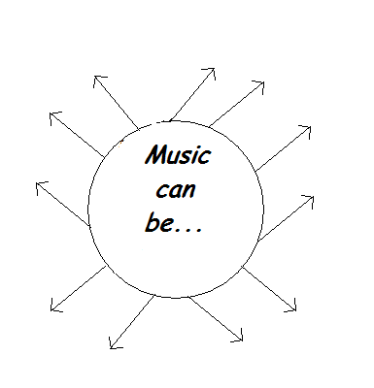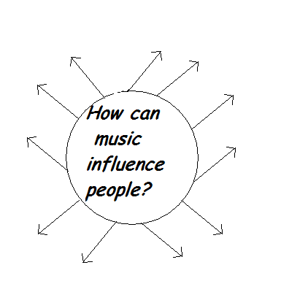

Рефлексия. Teacher: It`s the end of the lesson and the time for reflection, students. We have discussed much today. Did you like our lesson? I wonder what feelings and thoughts you`ve got now. Please, express your opinion in your cinquain poetry. You know its structure.
Cinquain poetry:
1word (a subject or a noun)
2 words (adjectives) that describe word 1
3 words (action verbs) that relate to word 1
4 words (feelings or a complete sentence) that relates to word 1
1 word (a synonym of line 1 or a word that sums it up)

Here is the example:
Music
fantastic, romantic,
inspires, enriches, conquers
It wakes up in the morning
Melody

Work in pairs and then present them, please.

T. You know that English is an international language of business and communication. A lot of people speak English. I want to say that songs can be an effective tool in language teaching and learning. Songs are a powerful medium for acquiring new knowledge. Some people learn English through songs. And now I want you to look at the blackboard. There are some words there. Repeat them just after me.
trouble
seem
though
believe
suddenly
shadow
hang
hide
T. All these words are from the song “Yesterday”. Let us sing this song.
(все поют песню)
Yesterday
John Lennon and Paul McCartney
Yesterday,
All my troubles seemed so far away,
Now it looks as though they’re here to stay,
Oh, I believe in yesterday.
Suddenly,
I’m not half the man I used to be,
There’s a shadow hanging over me,
Oh, yesterday came suddenly.
Why she had to go I don’t know, she wouldn’t say,
I said something wrong, now I long for yesterday.
Yesterday,
Love was such an easy game to play,
Now I need a place to hide away,
Oh, I believe in yesterday.
Why she had to go I don’t know, she wouldn’t say,
I said something wrong, now I long for yesterday.
Yesterday,
Love was such an easy game to play,
Now I need a place to hide away,
Oh, I believe in yesterday.

T. So my dear friends, today you have had a good opportunity to express your attitude to music. You were creative at the lesson. I liked your music projects and I am going to put you good and excellent marks. You really did your best and I am extremely pleased to have such good pupils. Maybe you have some questions. We can speak and tell much else but it is time to finish. And your task for the next lesson is to do literary translation of a song “Yesterday” . Our lesson is over. Good luck! And good-bye!

