«English forged victory»

There are some topics which are urgent and important at all times. One of them is the topic of war. On the 9th of May a lot of people celebrate Victory Day. Victory Day is the most important holiday for Russian people. The Soviet Union won the victory in the Great Patriotic War in the name of peace and life on Earth. But this holiday is celebrated not only in our country, but in many other countries. On this day all mankind was liberated from the danger of fascism. More than a million Soviet soldiers gave their lives for the sake of the freedom of many foreign countries. That’s why this war is called the Second World War. The theme of war is very extensive and every its aspect is important. Today we’ll speak about the role of our allies in this war and the role of the English language in the war and in the process of winning a victory over the enemy.

  - What is associated with the word «war»? Give your associations.
Какие ассоциации у вас вызывает слово война? Предлагаем наши ассоциации.

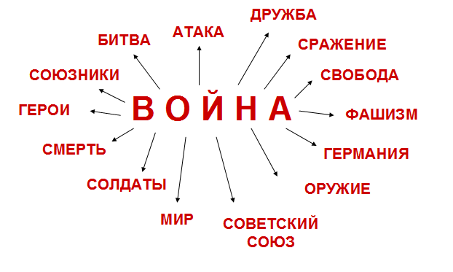

War: battle, attack, friendship, fight, freedom, fascism, Germany, weapon, Soviet Union, peace, soldiers, death, hero, allies.

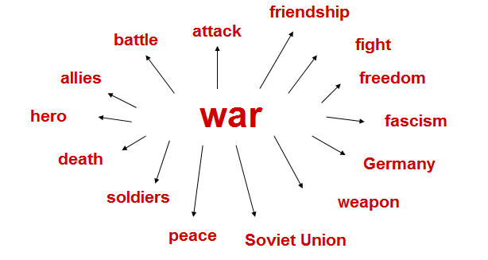

  - There were 62 countries taking part in the war. Among them there were English speaking countries: Great Britain, the USA, New Zealand, Australia, Canada and some other British colonies.

  - Science was very important in the years of war. Scientists invented new equipment and technologies to approach our country to victory and win the war. The English language played a very important role as well. We can’t overestimate the significance of the English language in the process of winning a victory. So, what is the role of English in this war? The first and the most important point is that English was used for communication between the Soviet leaders and soldiers and our allies, as many allied countries were English speaking countries. That’s why English was very essential and needed as a means of communication.

With the help of the English language people could:
- agree upon the mutual military assistance;
- exchange important data, information and technologies;
- arrange for economic assistance (for example land-lease);
- solve some political matters (for instance English was used during the Yalta and Teheran conferences as the common language. To come to an agreement and to make some important decisions Soviet leaders needed the interpreters.)

From the all above we can see that the English language helped a lot to precipitate the victory and its role was very important.

4. Синквейн.
1. Существительное
2. Два прилагательных
3. Три глагола
4. Фраза из 4 слов
5. Существительное

Война
Освободительная, кровавая
Сражаться, терять, выстоять
Нет страшнее этого слова
Смерть.

War
Terrible, awful
Fight, die, win
I hate any war
Blood

.

